Computer Science & Information Systems

**DevOps for Cloud - Lab Sheet 8 - Module 11**

**(M11: MLOps)**

This lab sheet needs to be administered along with Module 11: MLOps

**Notation used in the document**

* ‘>’ represents the terminal, where we type the commands.
* The text mentioned within ‘[‘ and ‘]’ brackets provides additional documentation for the step.

1. Objectives:
2. To demonstrate a simple MLOps experiment using the “MLFlow” tool
3. Pre-requisite:
4. Visual Studio IDE
5. A dataset (can select from kaggle.com. Ex: “Pima Indian Diabetes” dataset or “Titanic” dataset, for binary classification)
6. Basic knowledge of Python, and writing a ML Classifier code in Python
7. Lab Exercise:

**Task 1: Install MLFlow and import libraries**

1. Open Visual Studio IDE
2. Open the terminal, and execute the following commands.

> pip install mlflow

> pip install psutil

1. Import necessary Python and MLFlow Libraries to run the experiment

# Import necessary libraries

import pandas as pd

from sklearn.model_selection import train_test_split

from sklearn.ensemble import RandomForestClassifier

from sklearn.metrics import accuracy_score, classification_report, precision_score, recall_score, f1_score, confusion_matrix

import mlflow

import mlflow.sklearn

import psutil

import time

**Task 2: Write Binary Classifier code and MLFlow monitoring code**

* Create a file called “main.py” and copy the following code.
* The code is for the “Covid” dataset. [If you are using any other dataset, modify the code accordingly].

# Set the MLflow tracking URI to 'http'

mlflow.set_tracking_uri("http://localhost:5000")

# Function for data preprocessing

def preprocess_data(data):

    # Convert categorical variables to one-hot encoding

    data = pd.get_dummies(data, columns=['Gender', 'CovidSeverity'])

    # Split data into X (features) and y (target)

    X = data.drop('DischargeType', axis=1)

    y = data['DischargeType']

    return X, y

# Function for training the model

def train_model(X_train, y_train, max_depth=3, n_estimators=100):

    # Initialize the classifier

    clf = RandomForestClassifier(max_depth=max_depth, n_estimators=n_estimators, random_state=42)

    # Train the model

    clf.fit(X_train, y_train)

    return clf

# Function to evaluate the model

def evaluate_model(model, X_test, y_test):

    # Make predictions

    y_pred = model.predict(X_test)

    # Evaluate accuracy

    accuracy = accuracy_score(y_test, y_pred)

    print(f"Accuracy: {accuracy:.2f}")

    # Display classification report

    print("Classification Report:")

    print(classification_report(y_test, y_pred))

# Function to log model and system metrics to MLflow

def log_to_mlflow(model, X_train, X_test, y_train, y_test):

    with mlflow.start_run():

        # Log parameters

        mlflow.log_param("max_depth", model.max_depth)

        mlflow.log_param("n_estimators", model.n_estimators)

        # Log model metrics

        y_pred = model.predict(X_test)

        accuracy = accuracy_score(y_test, y_pred)

        precision = precision_score(y_test, y_pred, average='micro')

        recall = recall_score(y_test, y_pred, average='micro')

        f1 = f1_score(y_test, y_pred, average='micro')

        confusion = confusion_matrix(y_test, y_pred)

        mlflow.log_metric("accuracy", accuracy)

        mlflow.log_metric("precision", precision)

        mlflow.log_metric("recall", recall)

        mlflow.log_metric("f1-score", f1)

        # Log confusion matrix

        confusion_dict = {

            "true_positive": confusion[1][1],

            "false_positive": confusion[0][1],

            "true_negative": confusion[0][0],

            "false_negative": confusion[1][0]

        }

        mlflow.log_metrics(confusion_dict)

        # Log system metrics

        # Example: CPU and Memory Usage

        cpu_usage = psutil.cpu_percent(interval=1)

        memory_usage = psutil.virtual_memory().percent

        mlflow.log_metric("cpu_usage", cpu_usage)

        mlflow.log_metric("memory_usage", memory_usage)

        # Log execution time

        execution_time = {}  # Dictionary to store execution times for different stages

        # Example: Execution time for training the model

        start_time = time.time()

        model = train_model(X_train, y_train)

        end_time = time.time()

        execution_time["model_training"] = end_time - start_time

        # Log execution time for other stages similarly

        mlflow.log_metrics(execution_time)

        # Evaluate model and log metrics

        evaluate_model(model, X_test, y_test)

        # Log model

        mlflow.sklearn.log_model(model, "model")

# Main function

def main():

    # Load the dataset

    data = pd.read_csv("Covid_data.csv")  # Update with your actual file path

    # Preprocess the data

    X, y = preprocess_data(data)

    # Split the data into training and testing sets

    X_train, X_test, y_train, y_test = train_test_split(X, y, test_size=0.2, random_state=42)

    # Train the model

    model = train_model(X_train, y_train)

    # Evaluate and log to MLflow

    log_to_mlflow(model, X_train, X_test, y_train, y_test)

if __name__ == "__main__":

    main()

**Task 3: Run the experiment and monitor the ML Operations**

1. In terminal, run command:

> mlflow ui --host 0.0.0.0 --port 5000

2. Right click on “main.py” and "run in interactive terminal"

3. Open localhost:5000 in browser and see the experimental results

4. In the “mlflow” dashboard, you can find the new experiment.

Open the experiment, and view the following tabs.

* Overview
* Model Metrics
* System Metrics
* Artifacts

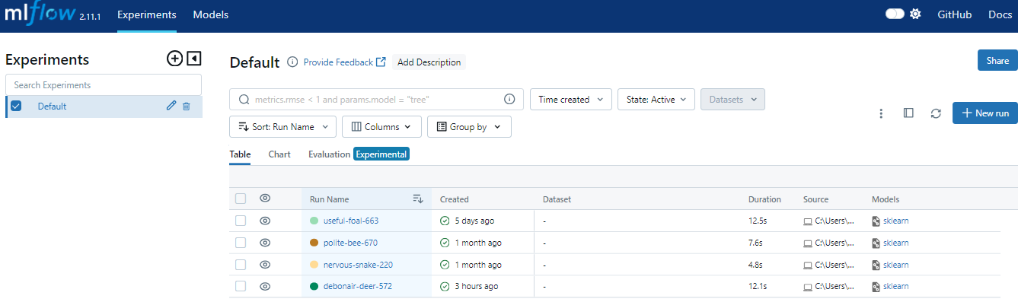

4. Outputs/Results:

Students are expected to perform the tasks provided in the lab capsule, and thereby gain a practical understanding of the MLOps concept using the MLFlow tool.

References:

<https://mlflow.org/>